DEPARTMENT OF BOTANY
RUSA SPONSORED WORKSHOP REPORT
A. Title of the Workshop: Skill-based Workshop on Organic Gardening

B. Background:
- Four days skill-based workshop on organic gardening was conducted.
- Mrs. Bhakti Khot (Proprietor, NuTreeGrow Consultants) was the resource person for the said workshop.
- Each day consisted of 45 minutes lecture session followed by 15 minutes question answers cum interaction and 2 hours hands-on training.
- Evaluation of the participants was done on the last day.
- Overall feedback was collected.

C. Aims/Objectives:
- To develop of hands-on skills among UG Botany students on organic kitchen gardening, microgreen cultivation, composting, medicinal plant cultivation, window gardening and organic control of pests and diseases.
- To motivate students towards using environment friendly practices required for plant cultivation in an urban set-up.
- To expose the participants towards career opportunities and consultancies in the field of organic gardening, for the development of entrepreneurial skills.

D. Location: Lab No. 2 Department of Botany, SIES College of Arts, Science & Commerce (Autonomous), Sion(W)

E. Target audience/participants with expected number: T. Y. B. Sc. (Applied Component – Horticulture and Gardening students). No. of Registered participants: 22
F. Details of Sessions:
Day | Content | Time
1st day | Lecture session: Organic Kitchen Gardening  - Definition, Objectives of organic gardening  - Organic gardening as consultancy and business  - Organic kitchen gardening – Introduction, Need, Scope  - Organic cultivation of plants in kitchen gardens at home-scale level | 45 mins
 | Interactive session: Question-answers and query addressing session. | 15 mins
 | Practical session: Common practices and techniques used in Kitchen gardening, potting, repotting, transplanting of saplings, cutting, pruning, weeding, etc. | 2 hours
2nd day | Lecture session: Microgreen Cultivation  - Microgreens as superfood – Introduction, Nutritional health benefits, Plants used  - Organic cultivation of microgreens at home-scale level | 45 mins
 | Interactive session: Question-answers and query addressing session. | 15 mins
 | Practical session: Common practices and techniques used in Microgreen cultivation | 2 hours
3rd day | Lecture session: Organic manures and fertilizers  - Organic manure and fertilizers – Overview, Applications, Composting.  - Organic control of pests and diseases – Overview and applications | 45 mins
 | Interactive session: Question-answers and query addressing session. | 15 mins
 | Practical session: Preparation of compost and liquid manures useful for plant cultivation, Preparation of organic farm liquid to control pests and diseases at home-scale level. | 2 hours
4th day | Lecture session: Window Gardening & Cultivation of medicinal herbs and ornamentals  - Do’s and don’ts of organic kitchen gardening  - Do’s and don’ts of Microgreen cultivations  - Medicinal plants and their health benefits  - Cultivation of medicinal herbs and ornamentals in window garden | 45 mins
 | Interactive session: Question-answers and query addressing session. | 15 mins
 | Practical session: Organic cultivation of medicinal herbs at home-scale level, Growing ornamentals in window gardening | 2 hours
- Evaluation and feedback collection at the end of the course.
G. Session and names of Resource Person: Mrs. Bhakti Khot, 2nd to 5th March 2022 - One session of three hours each per day.

H. Outcome:
- The participants learnt about the definition, concept, need and scope of organic farming.
- They got exposure towards hands-on skill development for soil, composting, vermicomposting, etc.
- They were able to create their own kitchen garden, microgreens.
- They learnt to utilize environmentally friendly practices such as use of organic fertilizers, use of biological growth promotors and organic control for pests and diseases.
- They were able to differentiate between good and bad practices of organic fertilizer & pesticides use in farming.
- The participants were exposed to current trends and career opportunities in organic kitchen gardening & commercial production of Microgreens.
WORKSHOP PHOTOGRAPHS

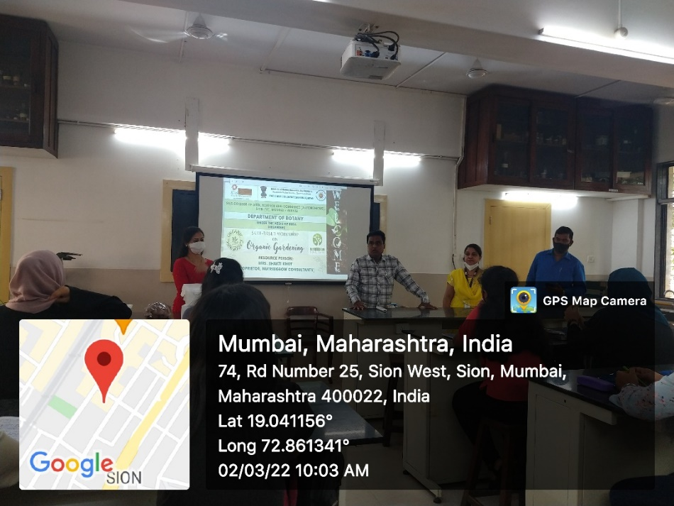
Day 1: Inaugural Function
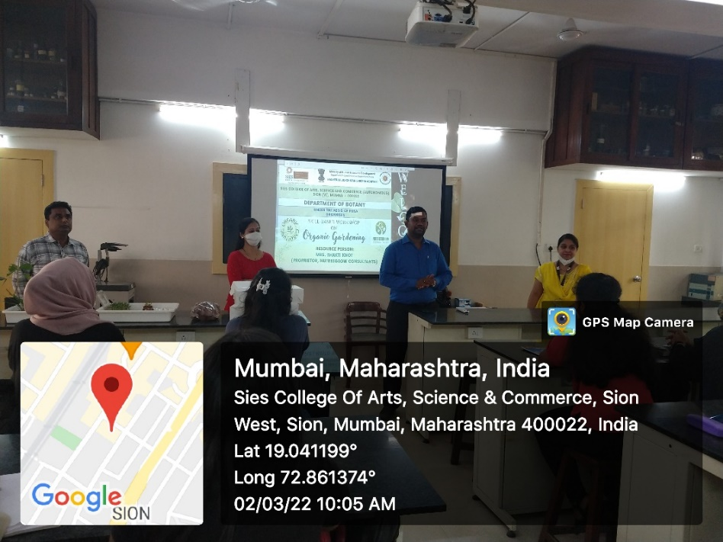
Day 1: Introduction of the Resource Person

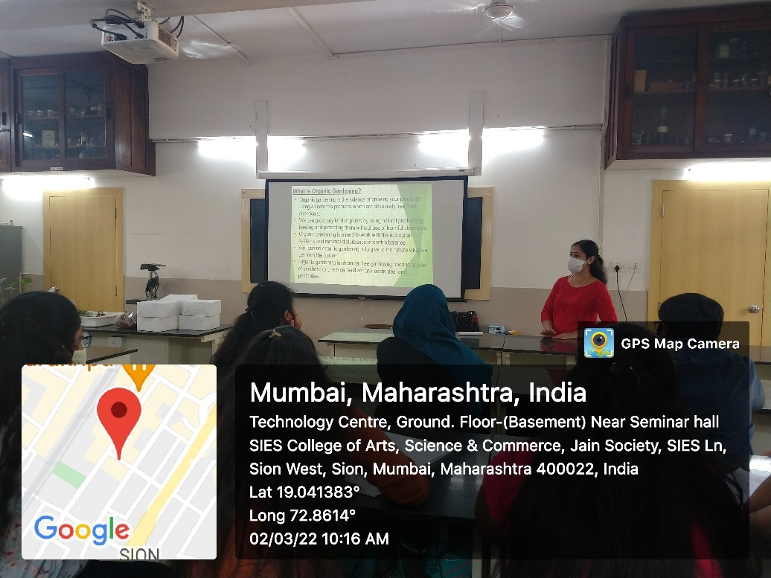
Day 1: Organic Kitchen Gardening – Lecture Session

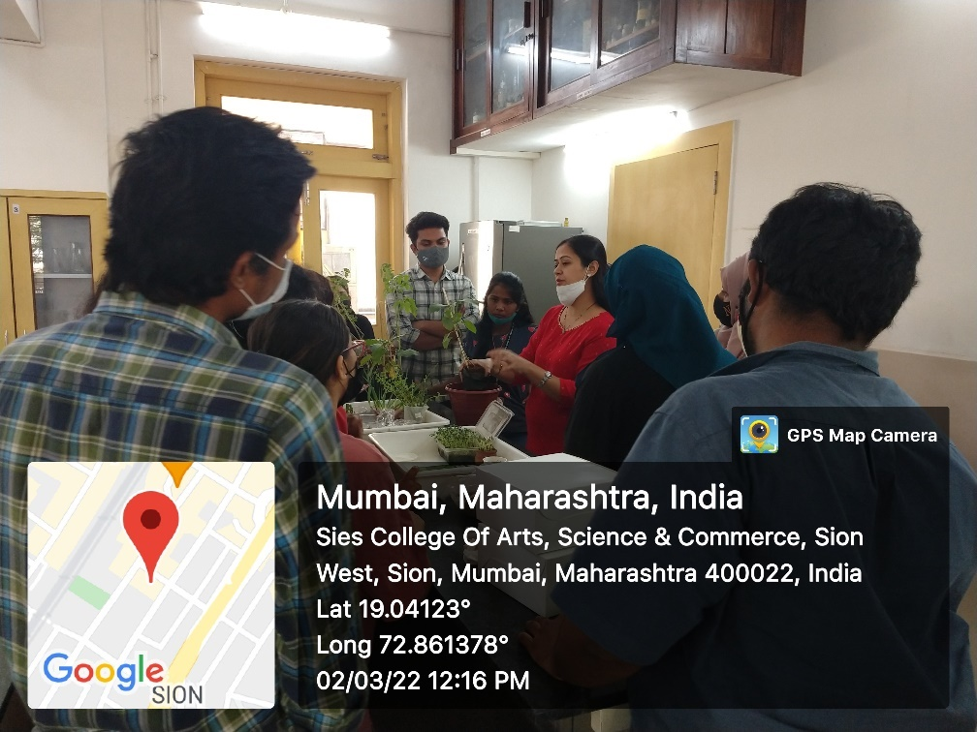
Day 1: Organic Kitchen Gardening – Practical Session

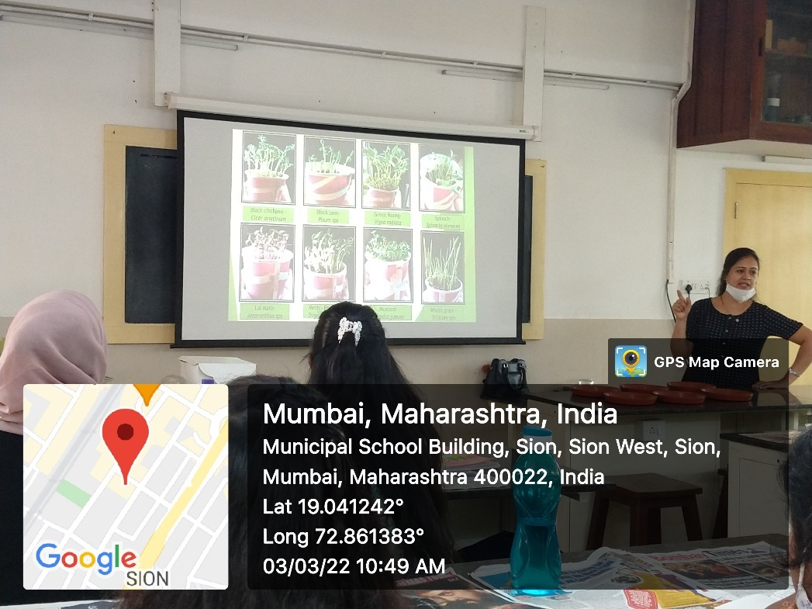
Day 2: Microgreen Cultivation – Lecture Session

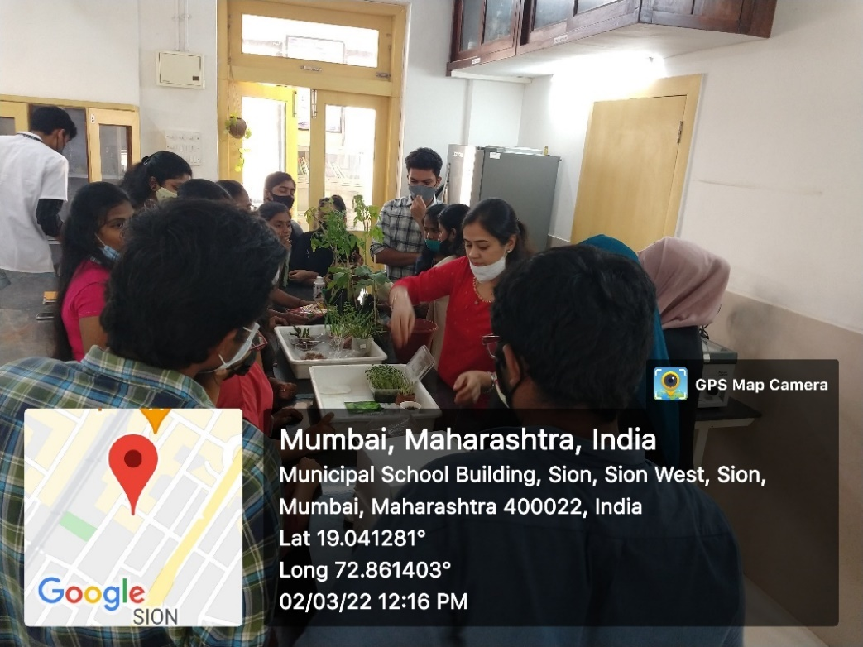
Day 2: Microgreen Cultivation – Practical Session

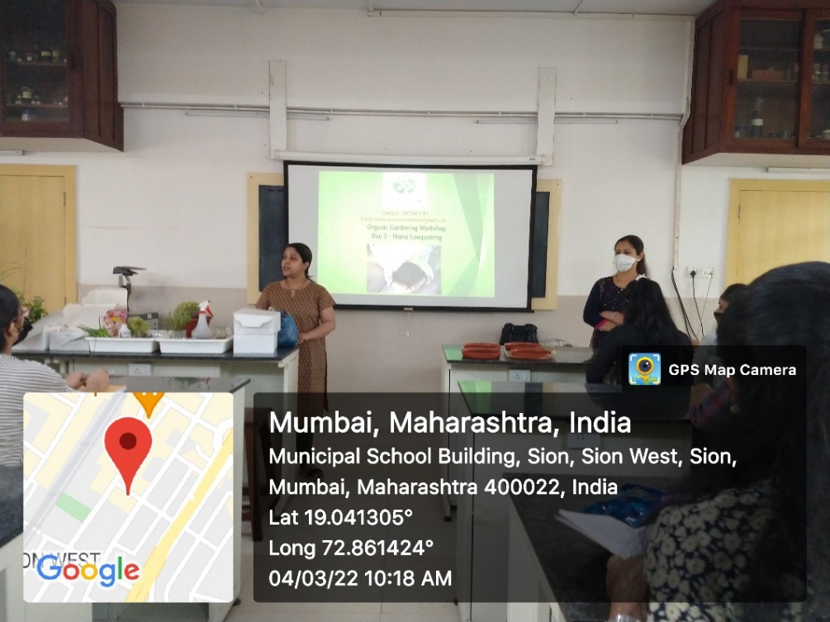
Day 3: Organic Manures and Fertilizers – Lecture Session

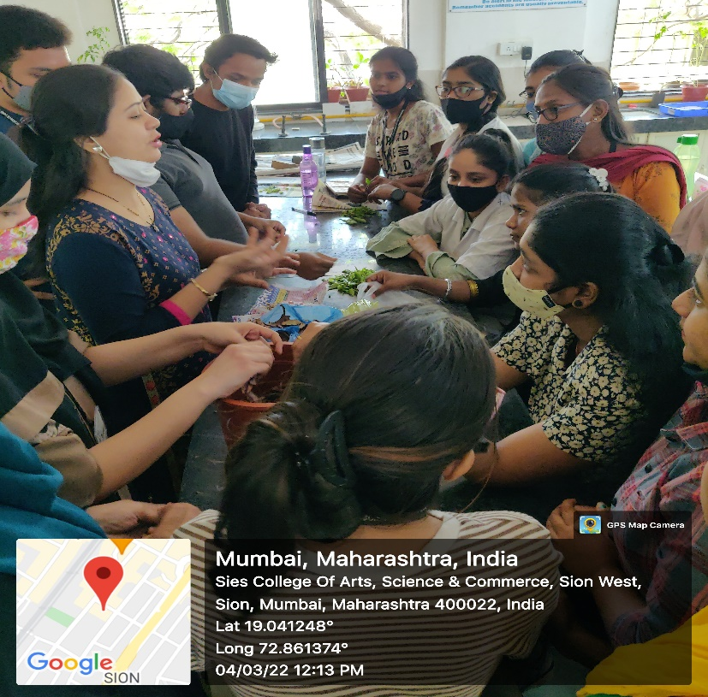
Day 3: Organic Manures and Fertilizers – Practical Session

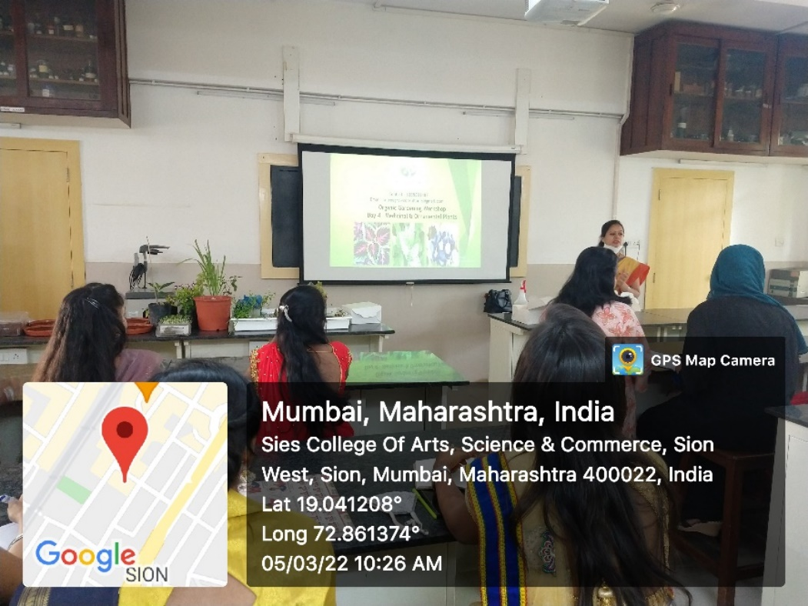
Day 4: Window Gardening & Cultivation of Herbs and Ornamentals – Lecture Session

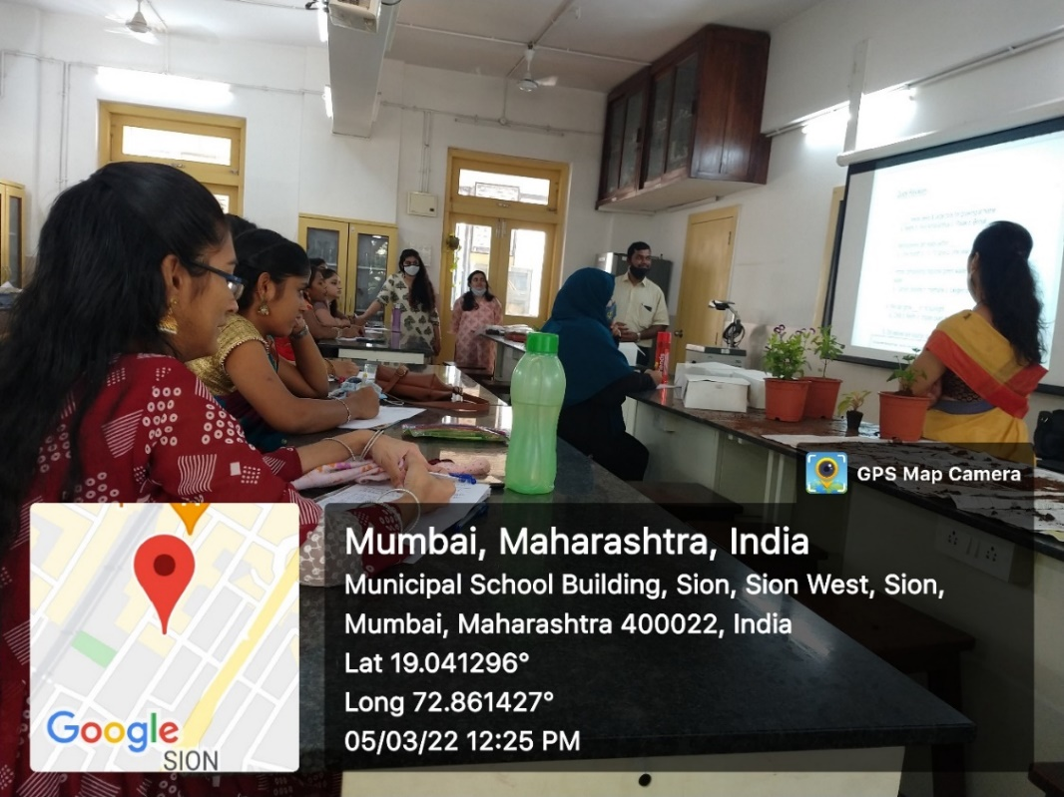
Day 4: Participants’ Evaluation

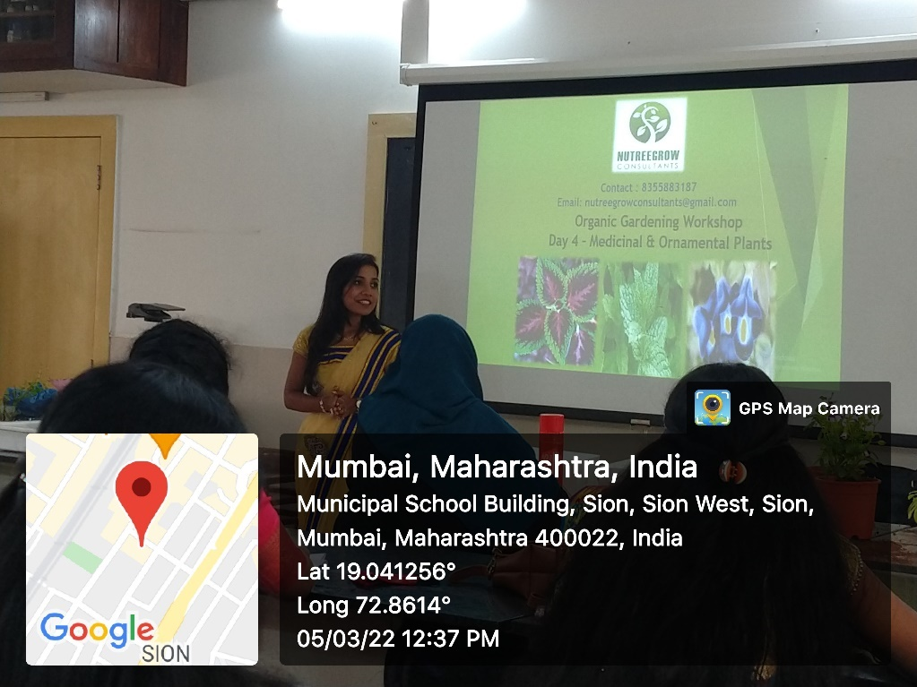
Day 4: Feedback by the Participant

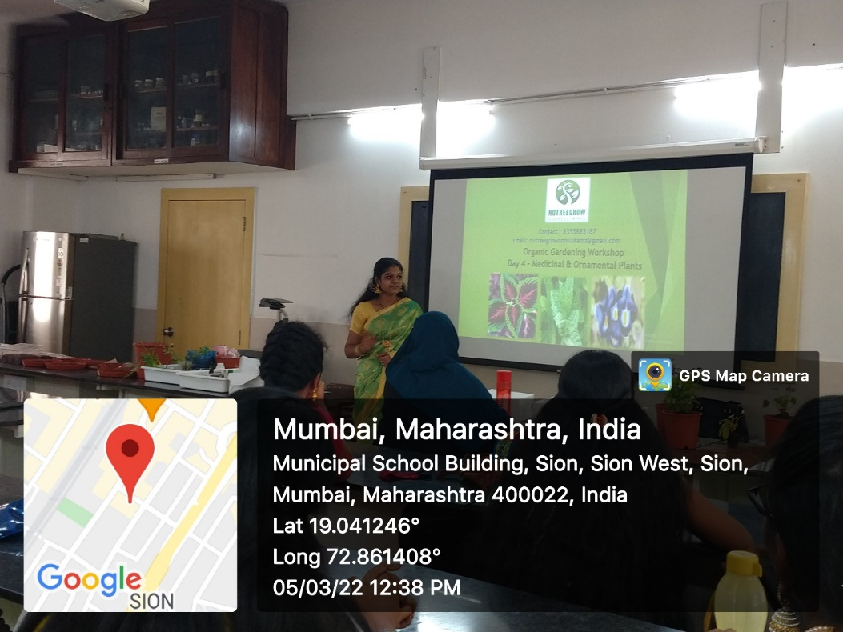
Day 4: Feedback by the Participant

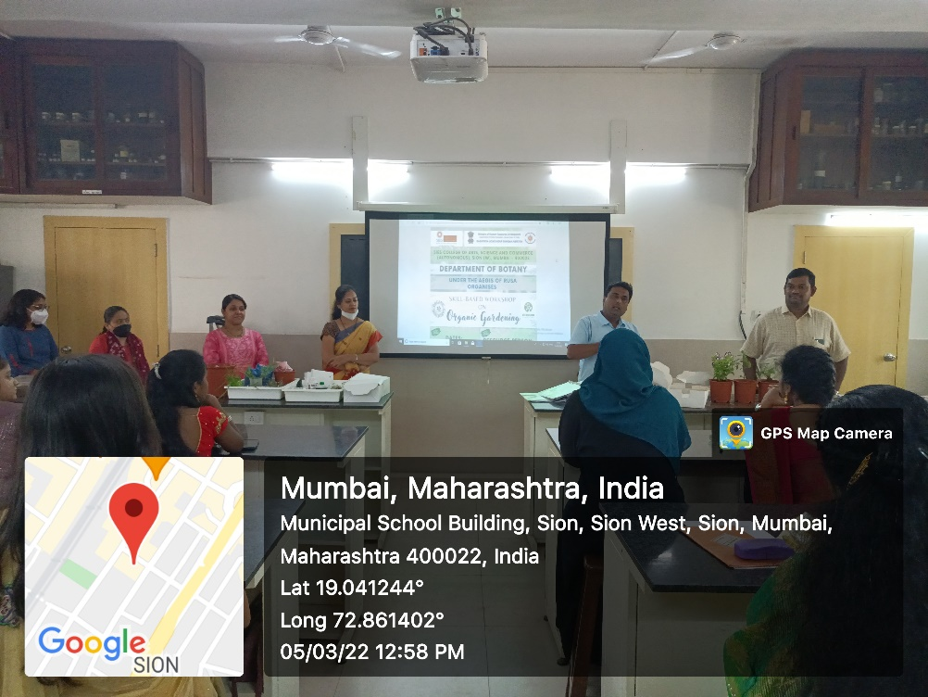
Day 4: Valedictory Function

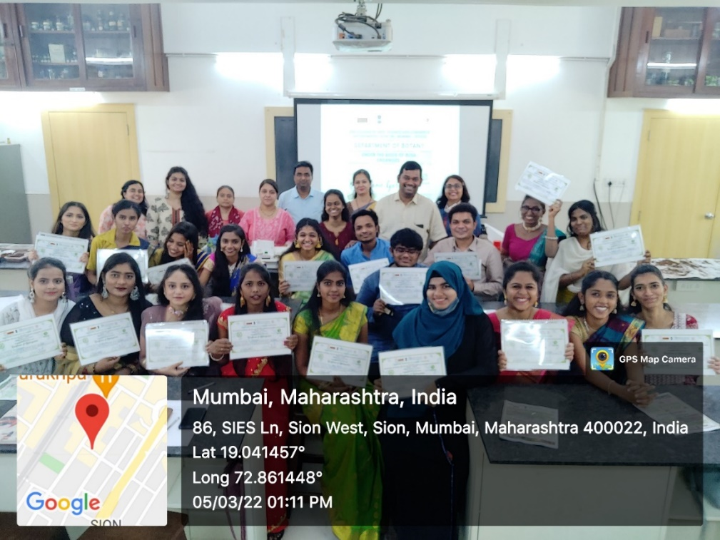
Day 4: Certificate Distribution

